(Approx. 1619 words)

Broadband Internet Technology
By Dick Maybach, Member, Brookdale Computer Users’ Group, NJ
March 2016 issue, BUG Bytes
www.bcug.com
n2nd (at) att.net

Early computer communication used voice-frequency modems and telephone lines, but this technology limits the bandwidth to less than 56 kbits/s. Initially, this was satisfactory, as files were small and most communication used only text. This was a time when an operating system easily fit onto a 1.2-Mbyte diskette, and the Internet was available only to colleges and the Defense Department. When the Internet began to grow, it was used mainly for e-mail, and the early Web sites made only scant use of graphics. This soon began to change however, and after a few unsuccessful attempts to use telephone lines to carry broadband signals, the cable television industry started to use their available bandwidth to provide truly broadband service. The chicken-and-egg dilemma was now resolved, and Websites quickly rushed to fill the available bandwidth. Software updates mailed on diskettes were replaced by downloaded ones, Websites spewed gratuitous graphics, and VCR rental stores disappeared in favor of downloads. What was at first novel is now expected, and few of us would be happy without broadband Internet service.

Initially (before the introduction of Internet service) cable TV carried analog TV using the same frequencies as broadcast service. Set-top boxes either weren't needed or merely shifted the channel frequencies to channel 3 or 4, depending on what button the user pushed. When telephone and Ethernet services were added, they were carried at frequencies not used by the TV channels. Later, as the number of cable channels increased, analog TV was replaced by digital service, and a set-top box was needed to convert the signal carried on the cable to one that a TV set could use. The sketch below shows the equipment needed for a cable TV system to provide TV, Internet, and telephone service to your home.

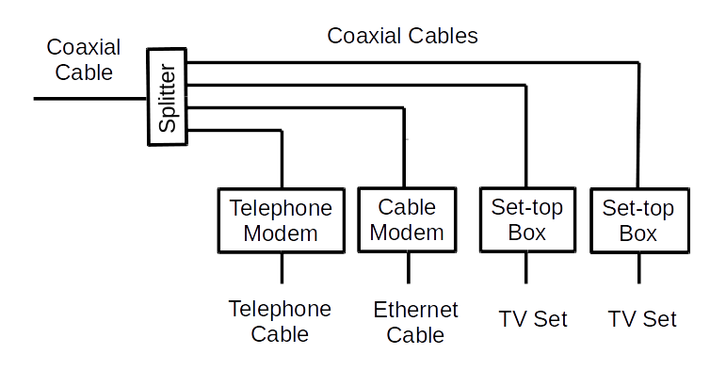

This system has some disadvantages.
- All the cabling is coaxial, which is relatively expensive, both to purchase and install.
- The splitter reduces the power available to the modems and set-top boxes. Because the splitter has losses, in the system shown each device will see less than one-quarter of the incoming signal power.
- Each service and each TV has a dedicated modem or set-top box.
- If the set-top box includes a recording function, the recorded programs are viewable only on the associated TV.
- If you connect more than one PC, you will have to purchase, install, and maintain a router that includes a switch. Similarly, if you want wi-fi in your home, you'll need an access point, although these are frequently incorporated in routers.
However, these disadvantages are relatively minor.

A newer technology brings the signal into the house and connects to an interface box that does all the signal conversion. The incoming signal can be whatever medium the ISP prefers (typically fiber optics or DSL), since it connects only to an interface box. All the ISP's services reside here, which simplifies installation and maintenance. Often this includes expanded Internet access, which may include a router and switch to support multiple PCs via Ethernet and a Wi-Fi access point.

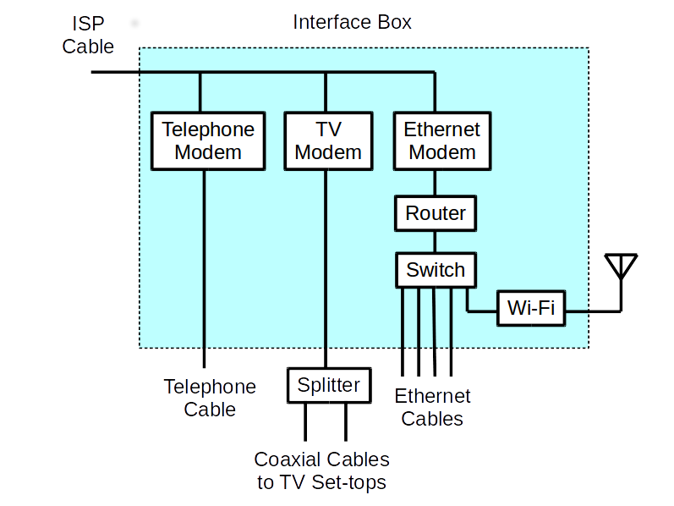

The TV signal is distributed through the house over coaxial cables, probably because that is what current set-top boxes expect, but this may change in time. In most cases, when this technology is installed it's to replace an existing cable-based system, which means houses in which it's installed already have coax installed. Coax does have the advantage that it needs only a simple splitter to support multiple TV sets, although as noted above, the reduced signal strength eventually limits their numbers. If the service includes video recording, it's usually done in the interface rather than the set-top box, which means the recordings can be viewed on any TV.

Fiber optics are becoming a common distribution medium. If the ISP offers “fiber to the home,” the ISP cable shown above will be fiber; if the service is “fiber to the curb,” the fiber will terminate in an enclosure at the street, and wires will carry the signal to each home. In the latter case, the last link is often high-speed DSL. Both DSL and telephone signals are carried on relatively cheap and easily installed two-pair cable, although each uses only a single pair. Ethernet cable is similar, but it has eight wires (cabled as four twisted pairs), although the service uses only four.

These two technologies usually carry TV and telephone as well as Internet service, and their vendors offer packages that provide all three services at attractive rates. The services discussed below provide only Internet and phone (DSL) or Internet only (wireless). When you compare prices, include the costs of all your communications. Typical speeds for these services are 20 Mbits/s download and 2 Mbits/s upload.

DSL, using existing telephone cables, can also carry broadband digital signals from a central office to subscribers, although at much lower speeds than for curb-to-home link. There are several flavors, with Asymmetrical Digital Subscriber Line (ADSL), which has a much higher rate for downloads than for uploads, being used by residential customers. The highest DSL rates are 1.5 Mbits/s for downloads and 256 kbits/s for uploads, but this is available only for those living close the telephone central office. Whether you can use this service depends on the distance to the central office, the condition of the telephone cables that connect you, and whether the telephone company has installed DSL locally. You must contact your local telephone company to find if DSL is available to you and its bit rate. As shown in the diagram, DSL brings both the telephone and the Internet signal to your home on the same cable, where filters separate the low-frequency audio signal from the higher-frequency broadband one. Then a modem converts the broadband cable signal to a standard Ethernet one.

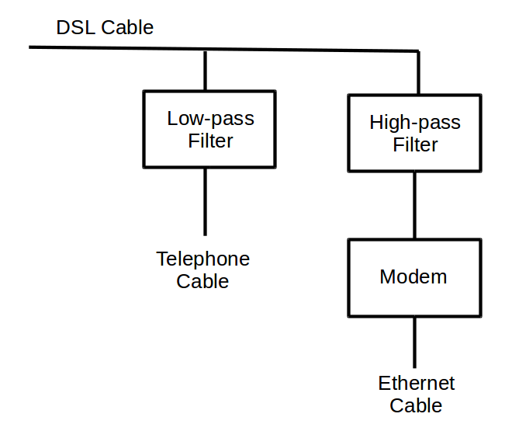

Wireless broadband connects a home or business to the Internet using a radio link between the customer’s location and the service provider’s facility. It often requires a direct line-of-sight between the wireless transmitter and receiver. Wireless Internet Services Providers (WISPs) provide such wireless broadband at speeds of around one Mbps, often in rural areas not served by cable or wire-line broadband networks. (Note the distinction between this kind of wireless service, which connects your home to an ISP, and a wi-fi hot spot that connects ISP's equipment to individuals in a home, building, or shop.) Mobile wireless broadband services are also becoming available from mobile telephone service providers and others. These services are generally appropriate for highly-mobile customers and require a special PC card with a built in antenna that plugs into a user’s laptop computer. Generally, they provide speeds in the range of several hundred Kbps.

Some services are not suitable for home users. ISDN, one of the telephone industry's early attempts at broadband service is expensive, obsolete, and slow. There is an ongoing attempt to use power lines to carry broadband signals, but trials have shown that power lines act more like antennas than transmission cables and produces unacceptable interference to existing radio communications. Finally, there are direct satellite links, which are too expensive for all but governments and businesses with large budgets.

DSL, like Plain Old Telephone Service (POTS) requires a separate dedicated wire pair between each customer and a central office. This is more expensive to install and to maintain than is a single high-speed bus, either electrical or optical, running down the street with hubs at which customers add or remove data packets. Given a choice, most customers will select a bus-based service, which provides TV, high-speed Internet, and telephone service at lower cost and higher speed than is possible with wire pairs. At present, Internet based telephone service is less reliable than POTS, but this will become less important the technology improves or more people switch to cell phones. As a result, I expect wire pair usage to decline, led by DSL but eventually followed by the telephone. For long-haul communication, fiber is king, because it has far more capacity than electrical cable. Radio communication will continue to occupy niches, for example satellite broadcasting, cell phones, and emergency services, but it too is limited by its relatively low capacity. There are legal issues. Typically, communication service is provided by companies who have negotiated monopolies with local governments. Initially, these monopolies were granted so that the vendors would be able to earn enough to repay the high installation costs. This may change as the costs of bus-based equipment continues to decline, but for the time being, your choice of vendors is limited.

Which of these should you use? If available, cable-TV and fiber-optic service provide the highest speed with neither offering a significant advantage. Just choose the ISP with the best price and reliability, with the realization that you may have to change. Competition is intense in this area, typically between cable TV and telephone companies. Since each typically has a monopoly supplying their native service, you usually will have no more than one available of each type. Without these, you will have to be satisfied with the lower transmission rate of DSL or wireless, at least in the short term. The coverage of high-speed service is constantly increasing, so you may soon find better speeds.
You may wish to get your e-mail service from a supplier other than your ISP. I've found changing e-mail addresses to be traumatic, as it requires informing not only my friends, but everybody with whom I do business over the Internet.

Regardless of what communications technology you use, knowing a little about what it is will help you use it effectively and make a good choice when you decide to change it.

